Week In Review
Alex Shvartsman

Pro Tour-New Orleans
This Pro Tour was won by a virtual unknown from Hamburg, Germany, whose previous tournament accomplishments include, but are not limited to, 19th place at 1999 Pro Tour-Chicago.
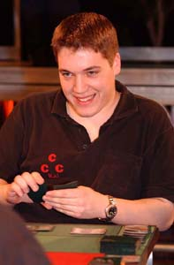
Kai Budde did it again. The Juggernaut continued a truly unbelievable streak, winning his fifth Pro Tour - and fourth in a row if you do not count Worlds. A few years ago, Budde improved on a High Tide design by adding red to his deck for Pyroblast, gaining a huge advantage in the mirror matchup as well as against control deck. Similar to the "Crimson Tide" strategy, was his Donate-Illusions variant this weekend. He splashed red for Pyroblasts and Fire/Ice, a strategy several of his teammates utilized as well, and one that placed Benedikt Klauser into the Top 8, too.
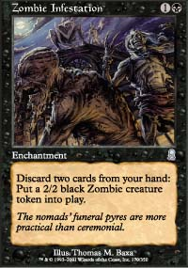
The New Orleans metagame could not have been more different from the one we've seen at Worlds earlier this year. Secret Force and TurboLand were among the most successful archetypes at Worlds - they crashed and burned in New Orleans, with few copies of either deck even advancing to Day 2. Instead, all sorts of craziness abounded. CMU played a Zombie Infestation/Squee combo deck. Your Move Games played a reanimator deck with a Contamination lock - a deck that put the struggling team back near the top, earning Kastle and Humpherys Top 8 finishes and the deck's designer Rob Dougherty a Top 16 finish. The Punisher's member Tomi Walamies played an Intuition/Call of the Herd combo that allowed him to finish second overall. Adrian Sullivan and Brian Kowal's group played a red-green weenie deck with threshold creatures such as Nimble Mongoose and Werebear, and Song of Blood to help achieve threshold quickly! The deck was not very successful (only Brian Davis finished in the money with it, making Top 48) but it was very original, and very much within the rogue spirit of this tournament.
I can't speak for others, but it was the first Constructed Pro Tour I really enjoyed in about a year. It was just fun playing the matches, with nothing outright broken in the format (though some decks are obviously better than others), and it was great watching some of the crazy things people would pull off. Ahh, only in Extended.
The Extended round of qualifiers is set to begin soon, and this Pro Tour provides a wealth of information to aspiring pros out there. It does not provide clear answers though - there are so many viable decks, and so many things that can be learned and done based on the information available to us, that the metagame actually emerging for the Qualifier season is anyone's guess.

New Orleans Masters

Mike Pustilnik defeated Chris Benafel in the final match of the New Orleans Masters Series, to become the first player to have won a Grand Prix, a Pro Tour and a Masters tournament. Bob Maher and Noah Boeken rounded off the Top 4. ABU was the most successful team at the tournament, placing three of its members into the Top 8 and earning a second place finish. The next Masters tournament is scheduled for San Diego. The format has not been announced officially yet, but it will most likely be Standard.

State Championships
The results have not come in yet, but State Championships took place around the country this weekend, setting the Standard metagame for the next few months to come. Invitational Standard decks heavily influenced the field but there was a fair amount of new decks as well. Here is a very limited list of states where I know the winning deck:
GA - Brian Kibler - u-g-r
NJ - John Sonne - u-g-r
AZ - Mitchell Tamblyn - r-g
Some of the more interesting decks that made various Top 8's included Battle of Wits based decks, and Upheaval/Zombie Infestation decks. More information will hopefully be forthcoming on The Sideboard over the next few days.

Coming Up: Grand Prix-Atlanta and Hong Kong
The Odyssey sealed/Rochester draft round of Grand Prix continues next weekend with events in Atlanta and Hong Kong. Atlanta will likely gather the usual crowd of pros and aspirants, and should probably top 500 people in attendance. Honk Kong will be much smaller, probably under 300 players, but it will feature an unusually high number of North American players. Among those planning to visit China next week are Brian Hegstad, Chris Benafel, Peter Szigeti, Dan Clegg, and yours truly. Other international players will attend, especially those from Singapore, Taiwan and Japan. Can Americans steal this tournament from the Japanese players who historically dominate the events in the region? Tune in to the coverage and find out.

Magic Online Announced
Wizards of the Coast posted a press release last week, announcing Magic Online - an interactive program that will allow players to play against each other over the internet. Far superior to independent programs such as Apprentice as well as the older attempts such as Microprose's Magic or The Interactive Magic Encyclopedia, Magic Online designed by Leaping Lizard Software is already generating a lot of very positive buzz among a fairly large group of players participating in the current alpha-test. The program is about to go into the more public beta-test state very soon and will probably be released by spring.
Full text of the press release: http://www.wizards.com/News/pressrelease.asp?20011105a

Magic Trivia
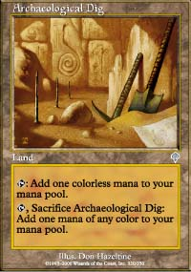
Last Week's Question:
Using only cards that are legal in Standard, how can you manage to have no cards in your hand AND no permanents in play at the end of your *first turn*, (you play first)?
Play Archaeological Dig. Tap/sac for or mana. Cast Rites of Initiation or Sacred Rites. Discard your whole remaining hand to whichever spell you chose to cast.
New Question:
Who was the first player to ever win a Pro Tour Qualifier?
Please do not email answers to me. Correct answer will be posted in the next column.

Quote of the Week
"Do these come with free installation?" - Terry Lau, purchasing sleeves at PT-New Orleans

Bad Play of the Week
Reported by Joost Winter
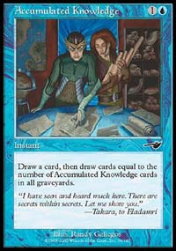
"The following happened in round 2 of Pro Tour-New Orleans, in my match against Matt Severa. I played an Oath deck which was nearly identical to that of third place finisher Jelger Wiegersma, and Matt was playing a u-b-r Finkel/Ophidian deck. We were playing the third and deciding game, and things were looking pretty good for me - though Matt had some Ophidians and Shadowmage Infiltrators on the table, I had an Oath of Druids, which would enable me to get 2 Morphlings (I sideboarded out the Weaver and Feeder for an additional Morphling) into play in a few turns. During my upkeep, I activated my Oath: at that point one Morphling was in play and the other in my graveyard, so Gaea's Blessing's effect would trigger and put back my graveyard into my library. I had an Accumulated Knowledge in my hand and - greedy as I was - I wanted to take advantage of the Oath/Blessing/AK synergy (putting AK's into the graveyard with Oath, and then play AK in response to the Blessing's triggered effect, enabling to draw more cards). So that is what I did: I activated my Oath, found no creature, Gaea's Blessing triggered, and in response I played AK for four. What I didn't realize was, that the AK would resolve before the Blessing's effect, at a moment where there were no cards in my library. So my opponent let my AK resolve, and I lost that game and match because I had to draw more cards than there were in my library... "
Got an interesting news story, comment, quote, play of the week, or Magic trivia to report? Please e-mail me at ashv80@hotmail.com.

